POWER BI CAPSTONE PROJECT
ShopNest Store
Power BI Capstone Dashboard Report
Sales, Revenue, Delivery, Product, and Customer Insights

Prepared by Rajkumar
Tool Used Microsoft Power BI Desktop

Contents
1. Project Overview
2. ShopNest Store Dashboard Overview
3. Order Status Analysis
4. Delivery Performance Analysis
5. Product Sales Analysis — Top Categories
6. Payment Method Analysis
7. Product Rating Analysis
8. State-Wise Sales Analysis
9. Seasonal Sales Pattern & Revenue Trend
10. Conclusion & Key Takeaways

1. Project Overview
- This project analyzes ShopNest Store e-commerce data using Microsoft Power BI Desktop.
- The dashboard delivers insights into sales, revenue, delivery performance, payment methods, product ratings, and state-wise sales.
- Interactive filters such as Year and Delivery Status let users explore the data dynamically.
All eight capstone questions are answered on a single-page interactive dashboard. Each analysis is documented below through its question statement, the corresponding visualization, and a concise explanation of the key findings.

2. ShopNest Store Dashboard Overview
- The dashboard combines all major business insights on one page for quick, at-a-glance analysis.
- Key KPI cards include Total Revenue (15.8M), Total Orders (99K), Delayed Orders (8K), and Average Order Value (159.33).
- Interactive Year and Delivery Status filters allow users to slice every visual on the page.
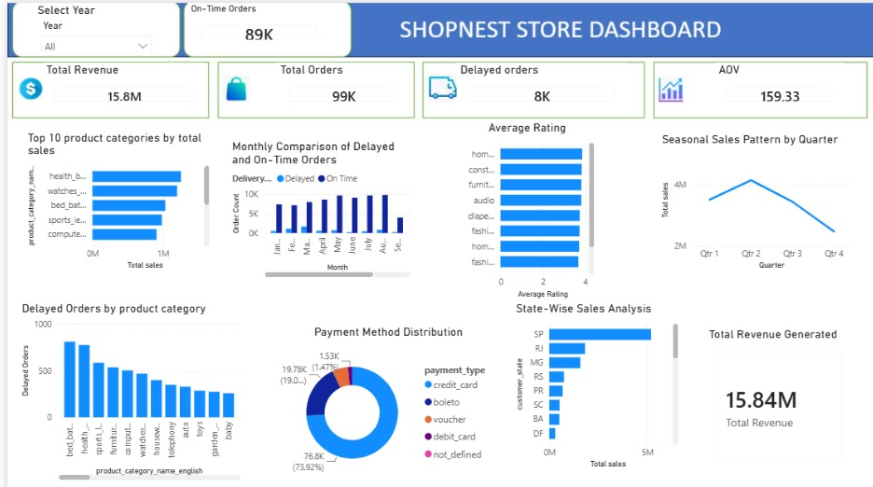
Figure 1 — Full ShopNest Store Power BI dashboard (single page).

3. Order Status Analysis
QUESTION STATEMENT
Analyze the distribution of orders based on delivery status — delivered, cancelled, shipped, unavailable, and other statuses.
VISUALIZATION
KPI cards summarising order outcomes: On-Time Orders, Total Orders, Delayed Orders, and Average Order Value.
Figure 2 — Order KPI cards: 89K on-time out of 99K total orders, with 8K delayed.
EXPLANATION & KEY INSIGHT
Out of 99K total orders, roughly 89K are delivered on time while about 8K are delayed and a small remainder fall into cancelled or unavailable statuses. The vast majority of orders reach customers successfully; tracking cancelled and unavailable orders highlights the operational gaps worth addressing.

4. Delivery Performance Analysis
QUESTION STATEMENT
Compare delayed orders against on-time orders across the months of the year.
VISUALIZATION
Clustered column chart showing Delayed Orders versus On-Time Orders by month.
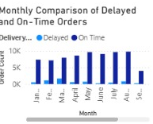
Figure 3 — Monthly comparison of delayed vs on-time orders.
EXPLANATION & KEY INSIGHT
The clustered columns reveal the months with the highest delayed deliveries, making it easy to evaluate delivery performance and target the problem periods for improvement.

5. Product Sales Analysis — Top Categories
QUESTION STATEMENT
Identify the top 10 product categories based on total sales.
VISUALIZATION
Horizontal bar chart ranking the top 10 product categories by total sales.
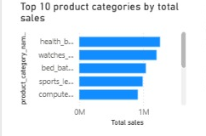
Figure 4 — Top 10 product categories by total sales.
EXPLANATION & KEY INSIGHT
The leading categories drive the largest share of sales and should be prioritised in inventory planning and promotional campaigns to maximise revenue.

6. Payment Method Analysis
QUESTION STATEMENT
Analyze the most frequently used payment methods by customers.
VISUALIZATION
Donut chart showing the split across credit card, boleto, voucher, debit card, and undefined methods.
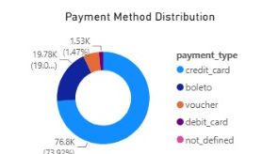
Figure 5 — Payment method distribution.
EXPLANATION & KEY INSIGHT
Credit card is by far the most preferred payment method (about 74% of transactions), followed by boleto. This insight guides checkout optimisation and payment-partner decisions.

7. Product Rating Analysis
QUESTION STATEMENT
Determine the highest-rated and lowest-rated product categories by average customer rating.
VISUALIZATION
Horizontal bar chart of average rating by product category (read top-to-bottom for best and worst rated categories).
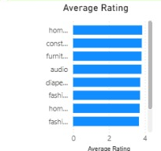
Figure 6 — Average rating by product category.
EXPLANATION & KEY INSIGHT
Highly rated categories indicate stronger customer satisfaction, while the lowest-rated categories flag where product quality, delivery, or customer service may need improvement.

8. State-Wise Sales Analysis
QUESTION STATEMENT
Identify the states with the highest and lowest total sales.
VISUALIZATION
Horizontal bar chart ranking states by total sales.
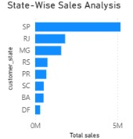
Figure 7 — States ranked by total sales.
EXPLANATION & KEY INSIGHT
A small number of states (led by SP) generate most of the sales, while the lower-performing states reveal regions where additional marketing or business development could unlock further growth.

9. Seasonal Sales Pattern & Revenue Trend
QUESTION STATEMENT
Analyze quarterly sales patterns and the overall revenue trend across the year.
VISUALIZATION
Line chart of total sales by quarter, supported by a Total Revenue card visual.
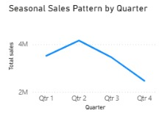
Figure 8 — Total sales by quarter.
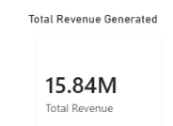
Figure 9 — Total Revenue card visual (15.84M).
DAX MEASURE — TOTAL REVENUE
Total Revenue =
SUM('order items'[price]) +
SUM('order items'[freight_value])
EXPLANATION & KEY INSIGHT
Sales peak mid-year (around Q2) and then taper toward Q4, revealing the store's strongest and weakest trading periods. The Total Revenue measure — the sum of item price and freight value across all order items — totals 15.84M, giving a single, reliable figure for tracking revenue over time and supporting seasonal planning.

10. Conclusion & Key Takeaways
- The dashboard provides a complete overview of ShopNest Store business performance on a single page.
- Sales analysis identifies the top-performing product categories and states, guiding inventory and marketing focus.
- Payment analysis shows customer payment preferences, led clearly by credit card.
- Delivery analysis helps identify delayed-delivery patterns by month and category.
- Product rating analysis highlights where customer satisfaction is strong and where it needs improvement.
- Revenue and seasonal trends support better planning, inventory management, and business decisions.
Together, these analyses turn raw ShopNest Store e-commerce data into an actionable, decision-ready view of the business.

